**CSC 250 – Program Design Document**

**John Akujobi S02Spring 2023**

**Structure Chart**

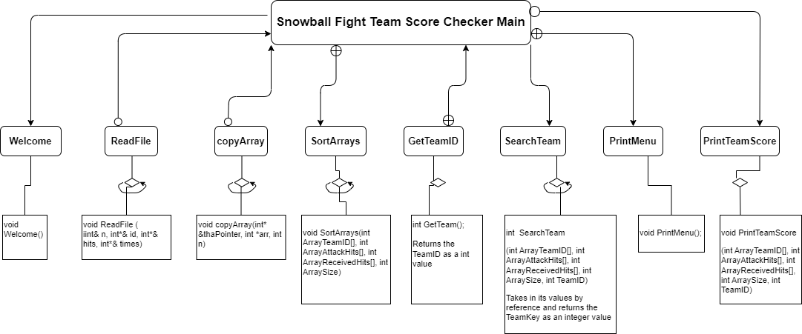

**Flowchart**

* Print the welcome message to the screen
* Open the file
* Fill the file contents into the 3 arrays; ArrayTeamID, ArrayAttackHits and ArrayReceivedHits
* Prints the menu
  + Option 1: Check team Score
  + Option 2: Quit the Program
* Receive user menu input, verify the input and call the option
* Read the team ID, and check if it is in the right format
* Search the list of array and find the team or print an error message
* Print the team ID, Attack hits, Received Hits
* Print Congratulations message if the Attack hits are more than the Received hits
* Repeat the loop
* After the user chooses the quit option, close the file
* End the program

**Function Design (give the prototype and a short description for each function)**

1. **Main**

It calls other functions

* + Prototype and Call
    - int main()
  + Memory and Variables
    - InputFile
      * This holds the input file “snowball.txt”
    - ArrayTeamID
      * This array holds the values for the Team IDs
      * int ArrayTeamID[]
    - ArrayAttackHits
      * This array holds the values of the Attack hits that the team made
      * int ArrayAttackHits[]
    - ArrayReceivedHits
      * This array hold the value of the hits received by the team
      * int ArrayReceivedHits[]
    - SIZE
      * Holds the size of the array which is the number of teams in the list
      * int SIZE
      * Gotten from the CalcArraySize function
        + SIZE = CalcArraySize();
    - MenuOption
      * This is the option that the user picks from the menu
      * int MenuOption
    - TeamReceivedHits
    - TeamAttackHits

1. **Welcome**

Prints a welcome message to the screen

* + Prototype and Function Call
    - void Welcome()
    - Welcome()

1. **ReadFile**

It opens the Input file “snowball.txt” and reads the that’s gotten from the input file into 3 arrays; ArrayTeamID, ArrayAttackHits and ArrayReceivedHits

* + Prototype and Call
    - void ReadFile(int ArrayTeamID[], int ArrayAttackHits[], int ArrayReceivedHits[], int &ArraySize)
    - ReadFile(ArrayTeamID, ArrayAttackHits, ArrayReceivedHits, ArraySize)

1. CalcArraySize

This function calculates the number of teams in the list, hence the size of the array and returns the size

* + Prototype and Call
    - int CalcArraySize(const int ArrayTeamID[])
    - CalcArraySize(ArrayTeamID[])
  + Memory and Variables
    - ArrayTeamID[]
      * Passed in from Main
    - SIZE
      * Local Variable holding the size
      * will be returned to the main function
  + Pseudocode
    - Calculate the size
      * int SIZE = **sizeof**(ArrayTeamID[]) / **sizeof**(ArrayTeamID[0]);
    - Returns the SIZE

1. **PrintMenu**

It Prints the menu to the user

* + Prototype and Call
    - void PrintMenu()
    - PrintMenu()

1. **GetTeamID**

It reads the team ID from the user, checks if it is in the right format and returns the integer TeamID

* + Prototype and Call
    - int GetTeamID()
    - GetTeamID()
  + Memory and Variables
    - TeamID
      * This is the ID of the team and is a 3 figure integer
      * int TeamID

1. **SearchTeamID**

It searches the user input using binary search and returns the TeamPosition in the array which represents i

* + Prototype and Call
    - int SearchTeamID (const int ArrayTeamID[], const int TeamID)
    - SearchTeamID (const int ArrayTeamID[], const int TeamID)

1. **PrintTeamScore**

This function prints the team ID, Attack hits, Received Hits and checks if the team won the snowball fight then prints a congratulatory message

* + Prototype and Call
    - void PrintTeamScore(int ArrayTeamID[], int ArrayAttackHits[], int ArrayReceivedHits[], int ArraySize, int TeamID)
    - PrintTeamScore(ArrayTeamID, ArrayAttackHits, ArrayReceivedHits, ArraySize, TeamID)

**Time Estimate**

|  |  |  |
| --- | --- | --- |
|  | **Estimated Time** | **Actual Time** |
| Program Design | **1:00 hr** | **3:18hrs** |
| (list each function name and the time required to code each) |  |  |
| Main |  |  |
| Welcome | **5 mins** | **2 mins** |
| **ReadFile** | **15 mins** | **50 mins** |
| CalcArraySize | **20 mins** | **25 mins** |
| **PrintMenu** | **10 mins** | **5 mins** |
| **SearchTeamID** | **30 mins** | **15 mins** |
| **PrintTeamScore** | **10 mins** | **7 mins** |
|  |  |  |
| Program Test | **2 hrs** | **Still testing** |
| **Total Time** | **4:30hrs** | **Still testing** |